Word Anagrams

[Submit solution](https://judge.telerikacademy.com/problem/03anagrams2/submit)

[My submissions](https://judge.telerikacademy.com/problem/03anagrams2/submissions/monika9158yahoocom/)

[All submissions](https://judge.telerikacademy.com/problem/03anagrams2/submissions/)

[Best submissions](https://judge.telerikacademy.com/problem/03anagrams2/rank/)

**Points:**100 (partial)

**Time limit:**0.3s

**Memory limit:**32M

**Author:**

[donchominkov](https://judge.telerikacademy.com/user/DonchoMinkovgmailcom)

**Tags**

Arrays, Strings

**Difficulty**

Easy

**Allowed languages**

C#, cpp, java, JavaScript, kt, php, Python, Swift

You are given a word **W** and words **WORDS**. You tasks is to check whether the words from **WORDS** are anagrams of **W**.

An anagram of a word is each word that has absolutely the same number of characters in any order. Example:

* The following are anagrams of "anagram":
  + "gramana", "aaagrnm", "margana", etc..
* The following are NOT anagrams of "anagram":
  + "aanagram", "aaagram", "anagra", "anagrama", "yxy"

**Input**

Read from the standard input

* On the first line, find the word **W**
* On the second line, find **N** - the number of words in **WORDS**
* On the next **N** lines, find a single word from **WORDS**

**Output**

Print to the standard output

* For each word from **WORDS** print either:
  + "Yes", if the word is an anagram of **W**
  + "No", if the word is NOT an anagram of **W**

**Sample tests**

**Input**

Copy

anagram

6

gramana

aaagrnm

anagra

margana

abc

xy

**Output**

Copy

Yes

Yes

No

Yes

No

No

Clarifications

No clarification

Alien Message

[Submit solution](https://judge.telerikacademy.com/problem/02alienski/submit)

[All submissions](https://judge.telerikacademy.com/problem/02alienski/submissions/)

[Best submissions](https://judge.telerikacademy.com/problem/02alienski/rank/)

**Points:**100 (partial)

**Time limit:**0.3s

**Memory limit:**32M

**Author:**

[martin](https://judge.telerikacademy.com/user/martintelerikacademycom)

**Tags**

Loops

**Difficulty**

Easy

**Allowed languages**

C#, cpp, java, JavaScript, kt, php, Python, Swift

Your task is to translate a message in some alien language (let's call it Alienski).

The message could be created by following simple rules and from two known languages, English and Spanish.

Each word in Alienski is constructed by subtracting the letters from English and Spanish (absolute value) and that is the resulting letter.

There are two special cases. If in each of the words the symbol is **'-'** (hyphen) or **' '** (space) it is mandatory for it to be kept this way.

**There won't be a case with a**'-'**(hyphen) and a**' '**(space) at the same time.**

If one of the words is with more letters than the other just add the letters from the longer word to the result.

**Example:**

Copy

talk

hablar

Copy

a b c d....

0 1 2 3....

1. t - h = | 19 - 7 | = 12 = m
2. a - a = | 0 - 0 | = 0 = a
3. l - b = | 11 - 1 | = 10 = k
4. k - l = | 10 - 11 | = 1 = b
5. empty - a = a
6. empty - r = r
7. Result:
   * makbar

**Input:**

Read from the standard input:

* Two lines with messages in English and Spanish
* Each message is on new line.

**Output:**

Print on the standard output:

* On the single line of the output, print the decoded message in Alienski

**Constraints:**

* All the letters will be small letters from the Latin alphabet and the special symbols **'-'** (hyphen) and **' '** (space).

**Hint**

* Use the ASCII table
  + **'a' - 'a' = 0**

**Sample tests:**

**Input**

Copy

thank you

muchas gracias

**Output**

Copy

hncgk idacias

**Note: There are two spaces here**

**Input:**

Copy

test

el examen

**Output**

Copy

ph pxamen

Clarifications

No clarifications have been made at this time.

Alpha Numbers

[Submit solution](https://judge.telerikacademy.com/problem/01alphanumbers/submit)

[My submissions](https://judge.telerikacademy.com/problem/01alphanumbers/submissions/monika9158yahoocom/)

[All submissions](https://judge.telerikacademy.com/problem/01alphanumbers/submissions/)

[Best submissions](https://judge.telerikacademy.com/problem/01alphanumbers/rank/)

**Points:**100 (partial)

**Time limit:**1.0s

**Memory limit:**64M

**Author:**

[edward](https://judge.telerikacademy.com/user/edwardtelerikacademycom)

**Tags**

Conditionals

**Difficulty**

Easy

**Allowed languages**

C#, cpp, java, JavaScript, kt, php, Python, Swift

Alpha numbers are a very special kind of numbers because they follow a very special rule - the biggest non-negative difference between all pairs must be larger than the last digit of the sum of all digits. Sounds hard?

For example, 186 is an alpha number.

* The non-negative differences are 8 - 1 = 7, 8 - 6 = 2 and 6 - 1 = 5.
* The sum of all digits is 1 + 8 + 6 = 15.
* The biggest difference 7 is larger than the last digit of 15.

**Input**

Exactly **7** numbers, each on a new line.

**Output**

Each alpha number on a new line, in the order given.

**Constraints**

100 <= number <= 999

**Sample tests**

**Input**

Copy

186

144

782

764

882

909

511

**Output**

Copy

186

909

**Input**

Copy

135

357

791

357

913

579

135

**Output**

Copy

791

913

579

Clarifications

No clarifications have been made at

EX.13: “MOVING LETTERS” (problem)

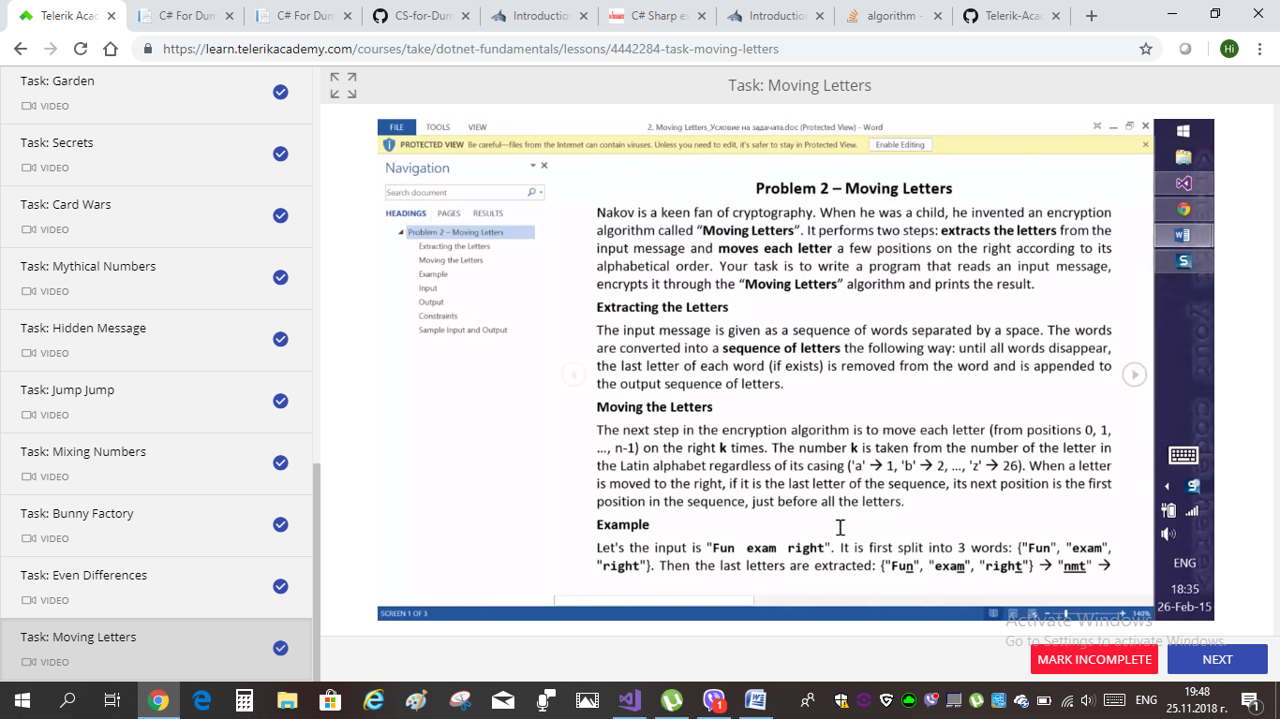

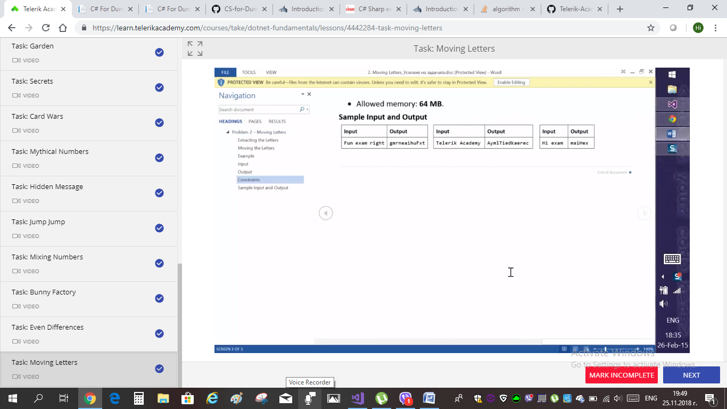

SOLUTION of ex.13: “MOVING LETTERS”

<all solutions pasted in this Word file R from VisualStudio LiveSolUtions project>

using System;

using System.Collections.Generic;

using System.Linq;

using System.Text;

using System.Threading.Tasks;

//using System.Numerics;

namespace LiveSolutions

{

class LivesolUtions

{

static void Main(string[] args)

{

///ex. 13: "Moving letters"; C# tools: sequence of letters;

//получаваме изречение, което да разделим на ДУМИ, разделени със спейс

{

string[] words = Console.ReadLine().Split(' ');//ПРАВИМ СПЛИТ ОТ 'спейс ' кавички на чар с празно място!!!

StringBuilder result = ExtractLetters(words);//цъкнах да ги активирам в/у тях;//показали са се НАКРАЯ!!!

result = MoveLetters(result); //ползваме методи!//НАЙ-ОТДОЛУ!!! те са ни цялата задача...

Console.WriteLine(result.ToString());

}

///как ще вземе последните букви на всяка дума?

///a.k.a. ExtractLetters -PRAVIM SI METHOD -implementing a method // имплементираме метод

///НА НАЙ_ДОЛНИЯ РЕД ТУК ВЪВ ВИЖУАЛ СТУДИО МИ СЕ Е ПОЯВИЛО КАТО ЦЪКНАХ ВЪРХУ ДВАТА МЕТОДА ДА ГИ ВЪВЕДА

///НАЙ_ДОЛУ СКРОЛНИ ЗА ДА НАМЕРИШ ВАЛИДНОТО private static string ПОлЕ за ExtractLetters и MovеLetters

/////////////////

///example input 1: Fun exam right (output: gmrneaihuFxt)

///ex.input 2: Telerik Academy (output: AymlTiedkaerec)

///ex.input 3: Hi exam (output: maiHex)

///EX.13: MOVING LETTERS - апендикс за МЕТОДИ за думите букви макс. дължина дума и т.н.

private static StringBuilder MoveLetters(StringBuilder builder)

{

//правилно: for;///GRESHNO: foreach (char letter in result) //foreach e samo ako znaem poziciqta

for (int i = 0; i < builder.Length; i++)

{

char letter = builder[i];

int indexInAlphabet = Char.ToLower(letter) - 'a' + 1;//Char za da ne proverqvame za GlAvNi i malki

MoveRight(builder, i, indexInAlphabet);

//буквата на позиция i да я преместя с indexInAlphabet на брой елемента;

}

return builder; //return veche updatenatiq result

//MoveRight също си цъкваме и по-долу ни излиза ТРЕТИ private string

}

//ako ne se poqvi, si pisha direktno sama:

private static void MoveRight(StringBuilder builder, int index, int count)

{ //tuk sme VOID , a ne STING !!!

////premestvame v pss MoveLetters sledniq red: StringBuilder resultBuilder = new StringBuilder(result);

char letter = builder[index];

int position = index + count;

position %= builder.Length;

builder.Remove(index,1);

builder.Insert(position, letter);

///zaradi premestvaneto nagore na StringBuildera, v parviq private static string MoveLetters, otpada nujdata ot toze red:return resultBuilder.ToString();

}

private static StringBuilder ExtractLetters(string[] words)

{

StringBuilder builder = new StringBuilder();

//dolu: "za vsqka duma mi dai daljinata na dumata

//i ot vsichki daljini mi dai nai-dalgata duma":

int maxWordLength = words.Max(word => word.Length);

for (int i = 0; i < maxWordLength; i++) //"i "==simvol ot vsqka duma, t.e. bukva!?

{

foreach (string word in words)

{ //LUDNICAAAAAAAA

int index = word.Length - i - 1;//tai kato tova ne ok, ptavim bool proverka da ne go dopusnem:

bool condition = index >= 0;

if (condition)

{

builder.Append(word[index]);

}

}

}

return builder; ///!!!!!!!///za da se kompilira metoda

}

}

}

EX.12: „ EVEN diFFERENCES”

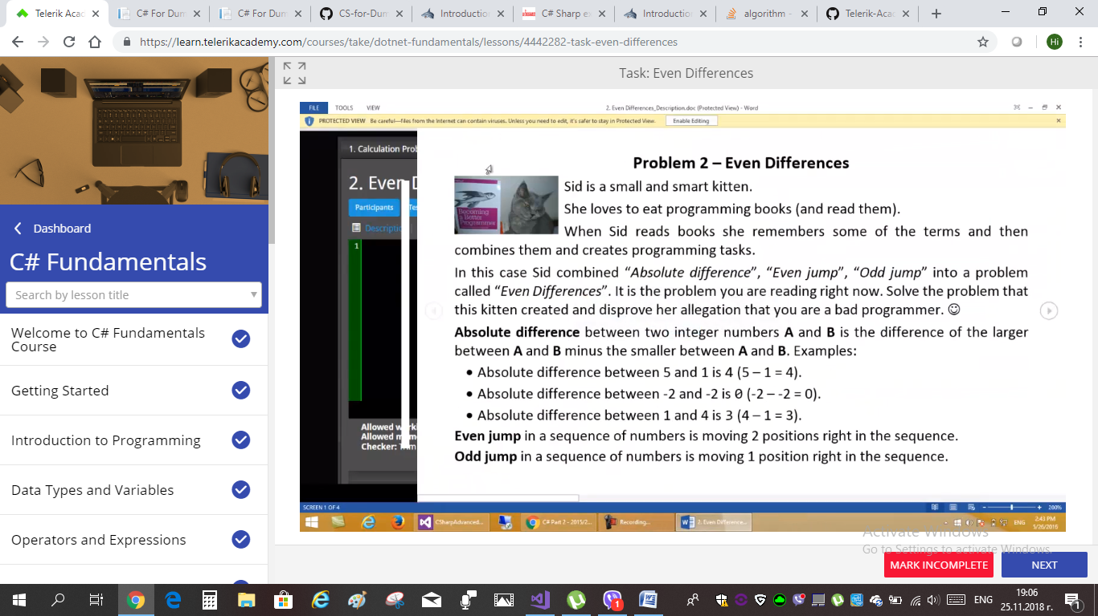

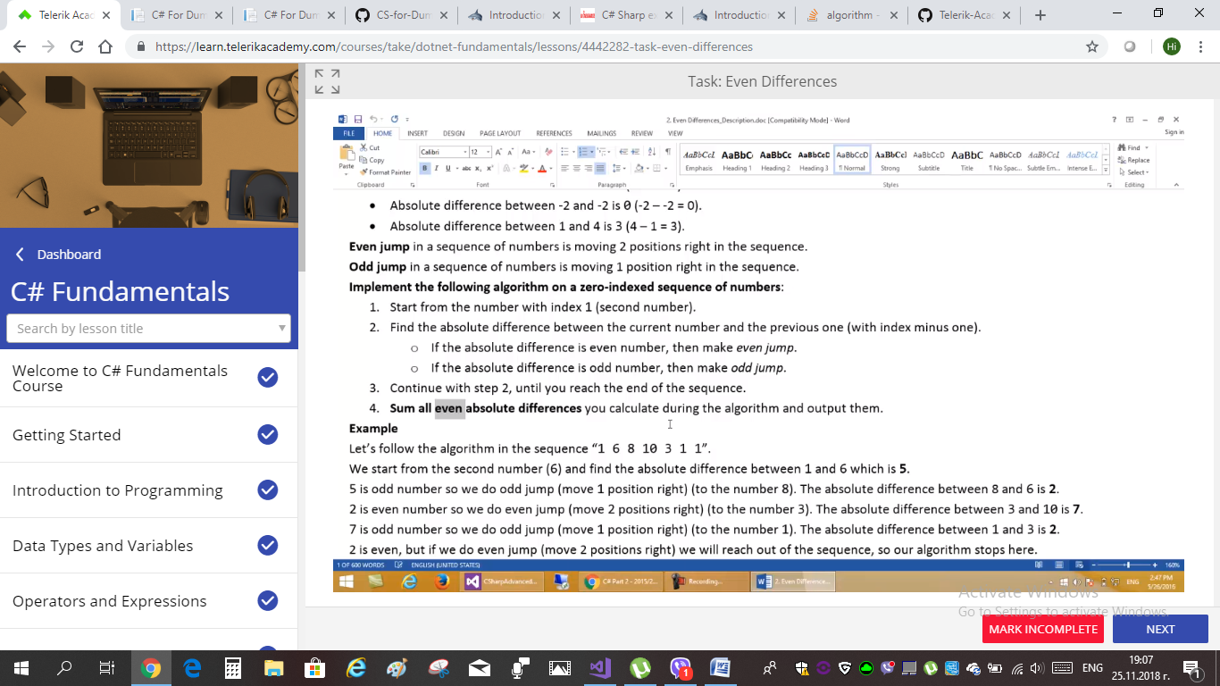

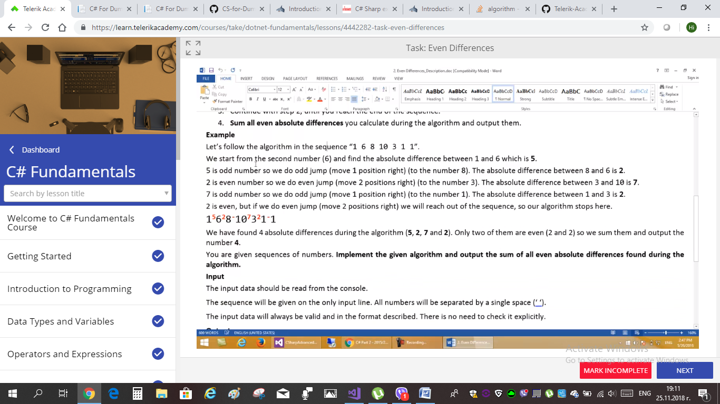

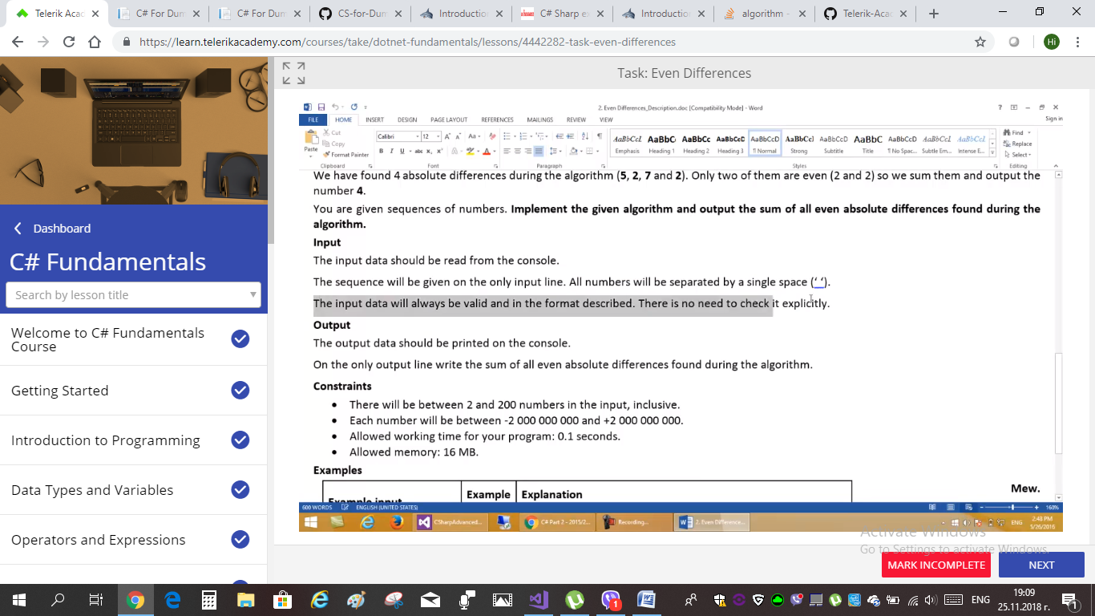

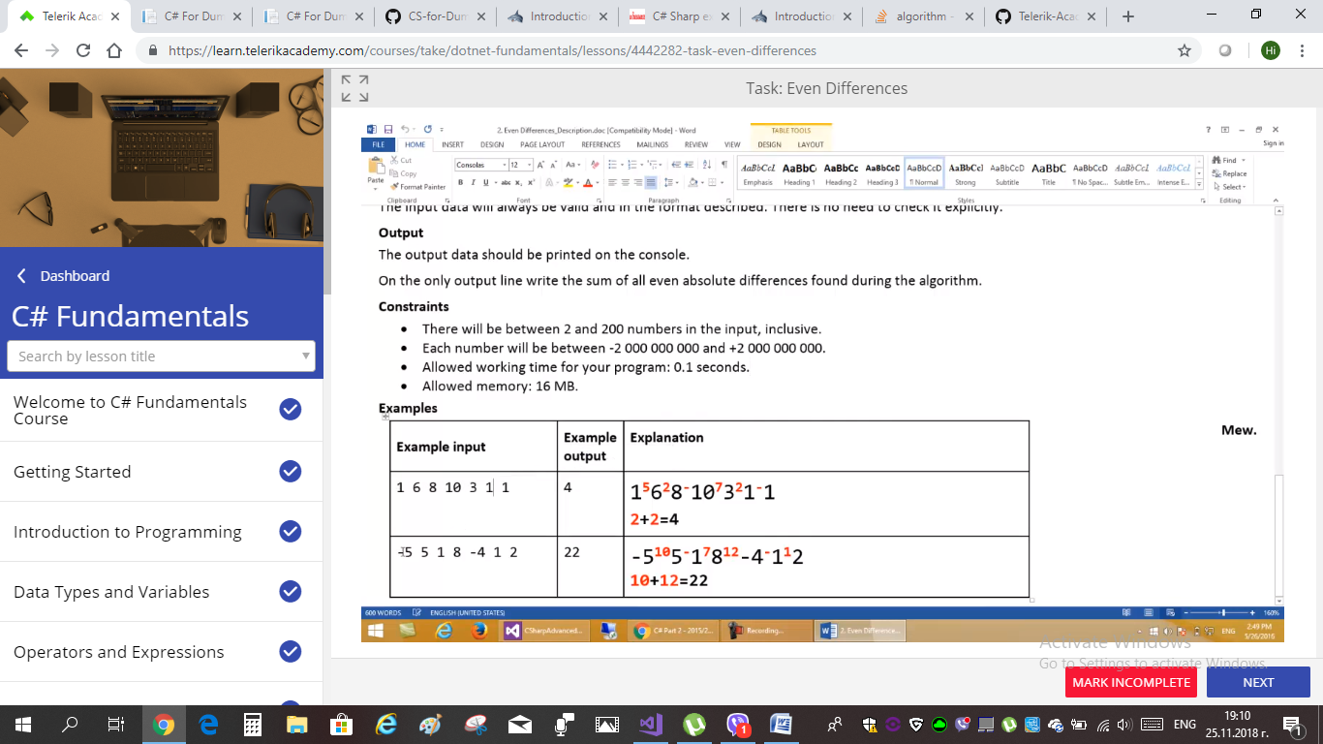

EX. 11: “Bunny Factory”

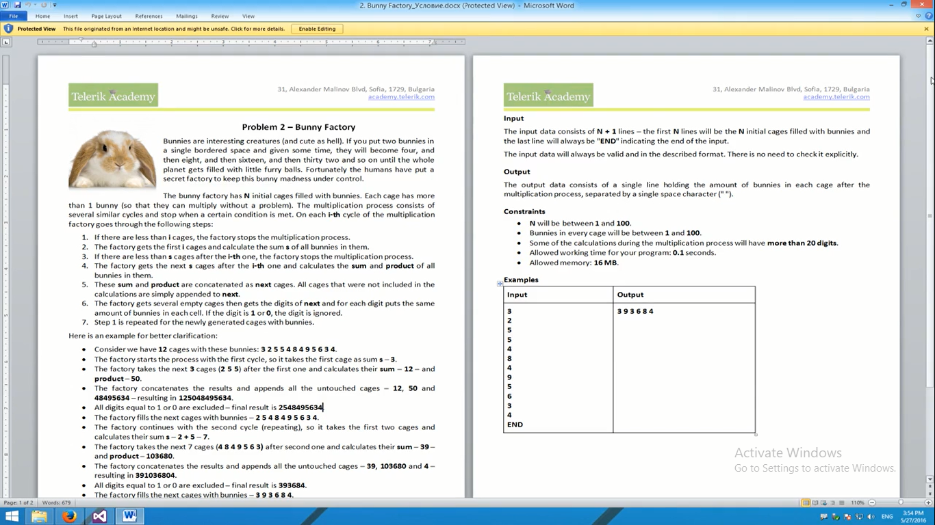



Copied input na zajovete ot EX. 11;

**3**

**2**

**5**

**5**

**4**

**8**

**4**

**9**

**5**

**6**

**3**

**4**

**END**

EX. 10: “Mixing Numbers”

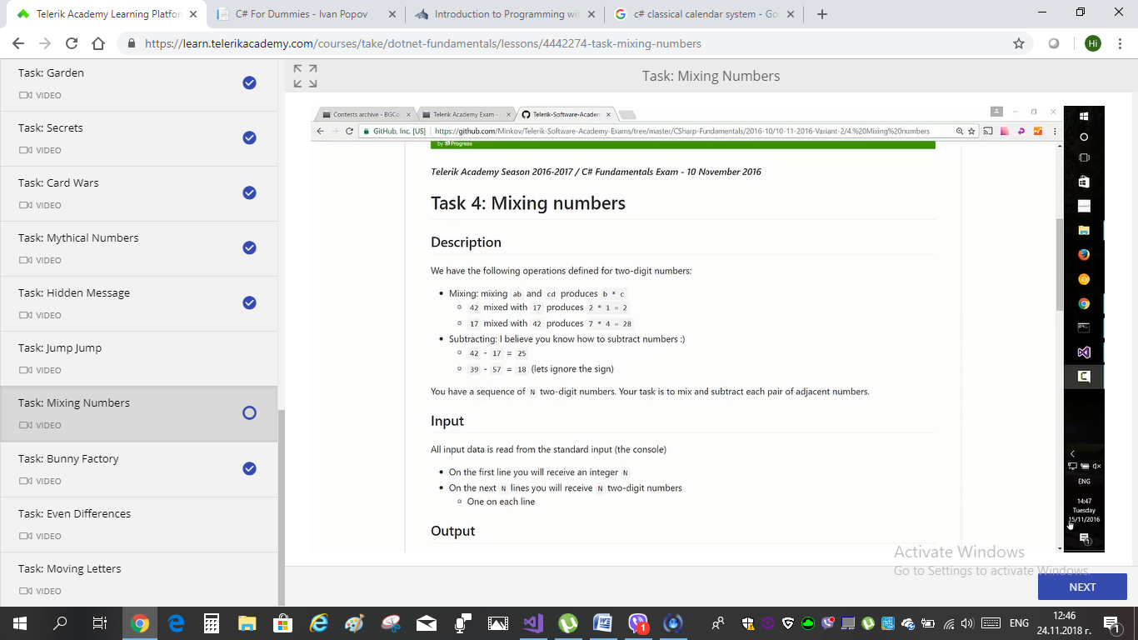

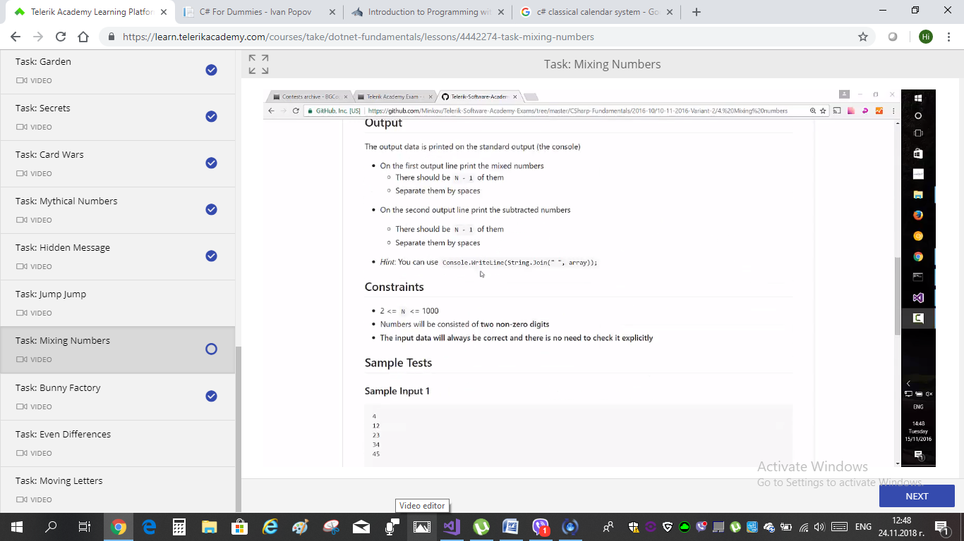

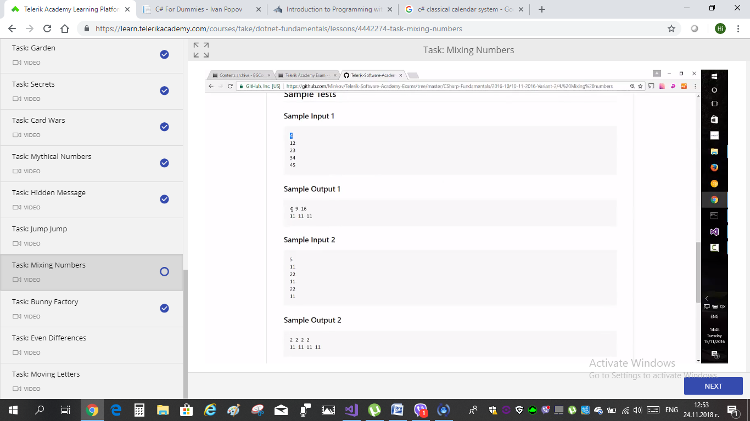

EX. 9: ‘Jump, jump’

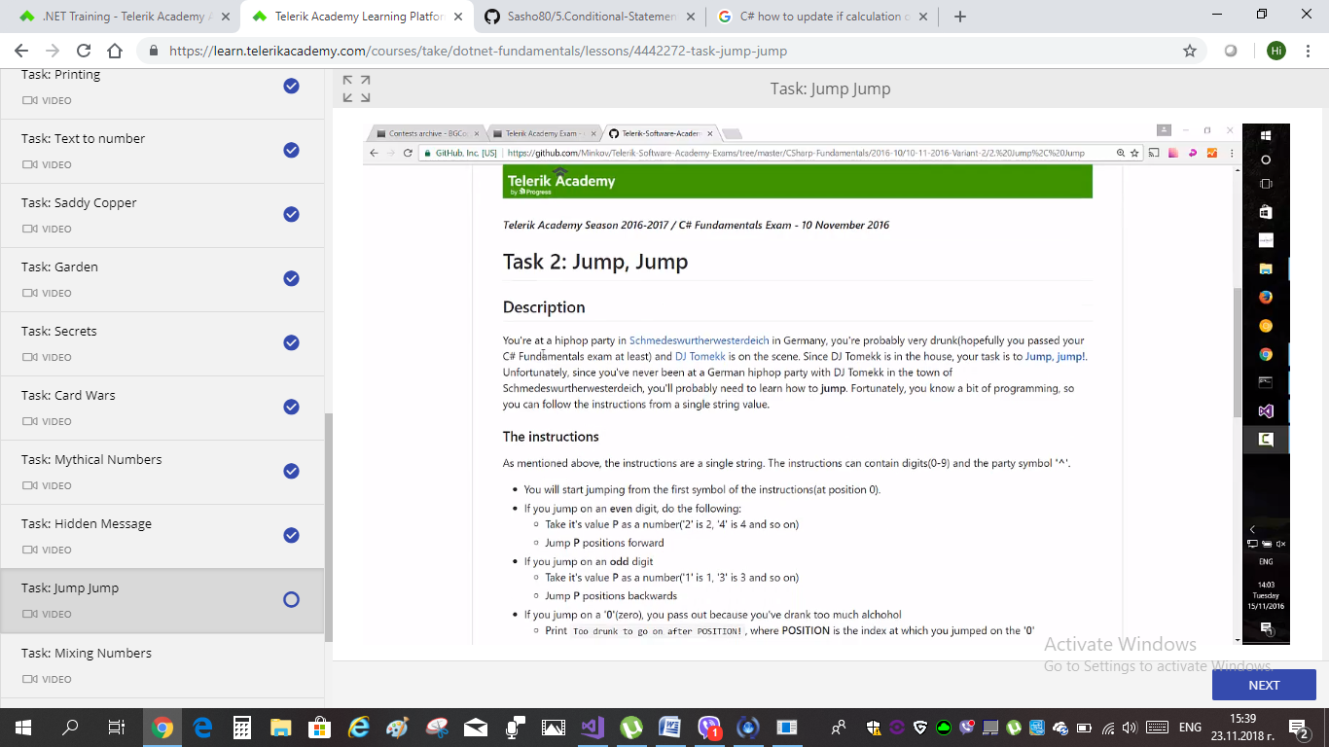

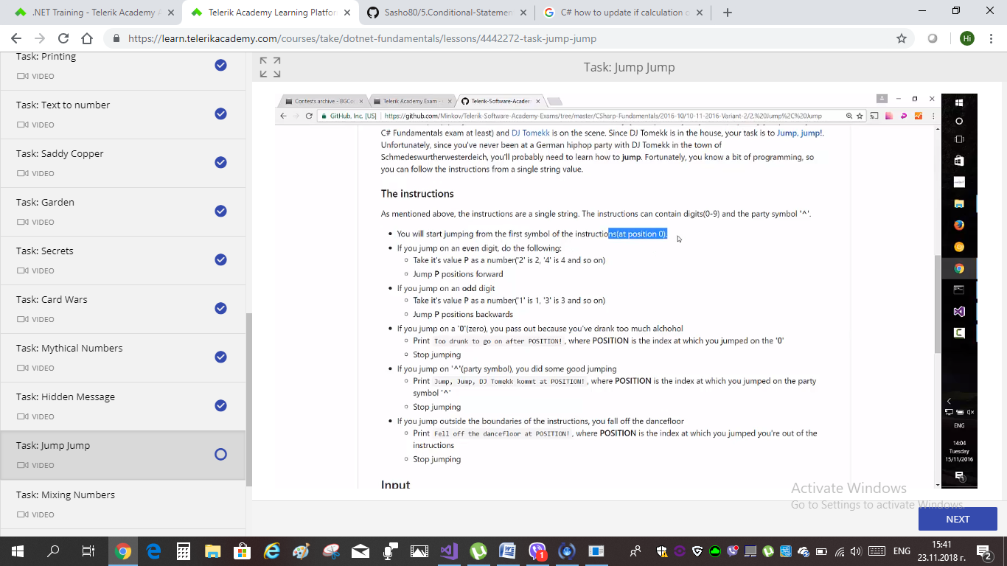

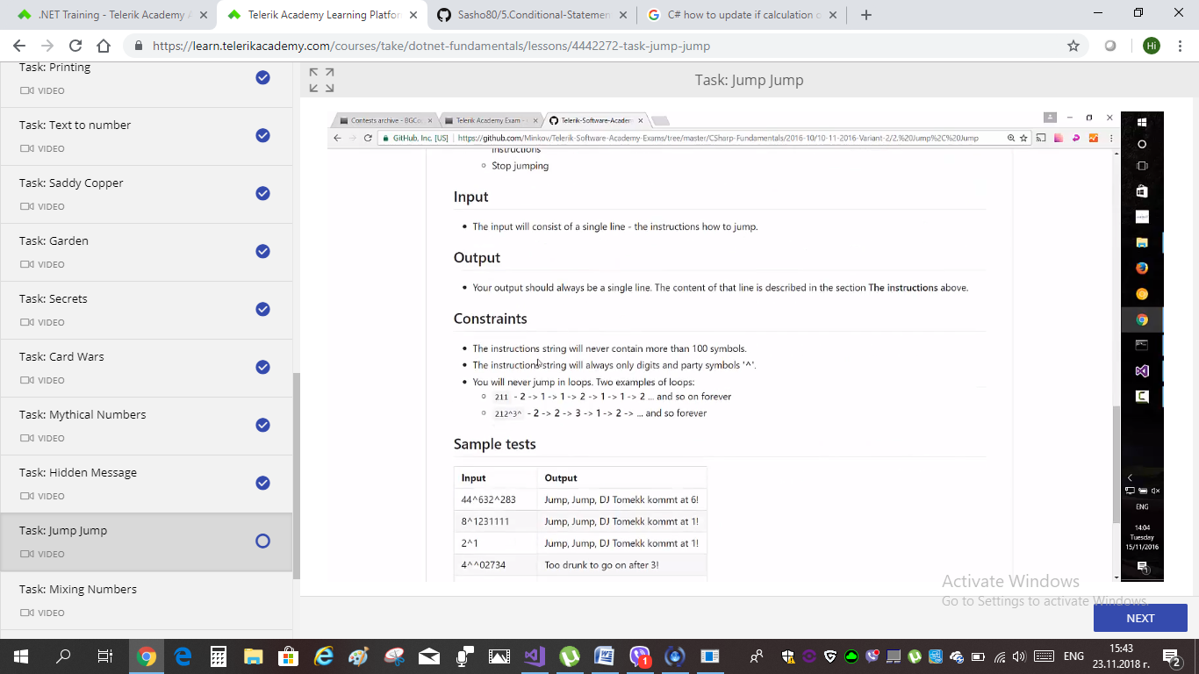

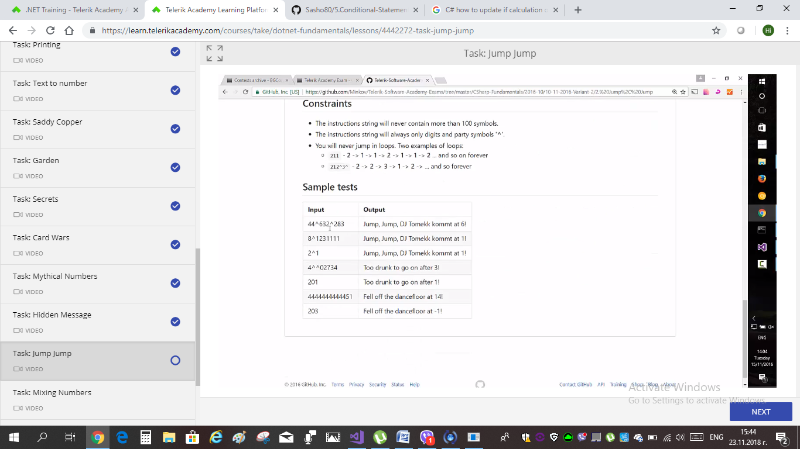

EX. 8: “HIDDEN MESSAGE”

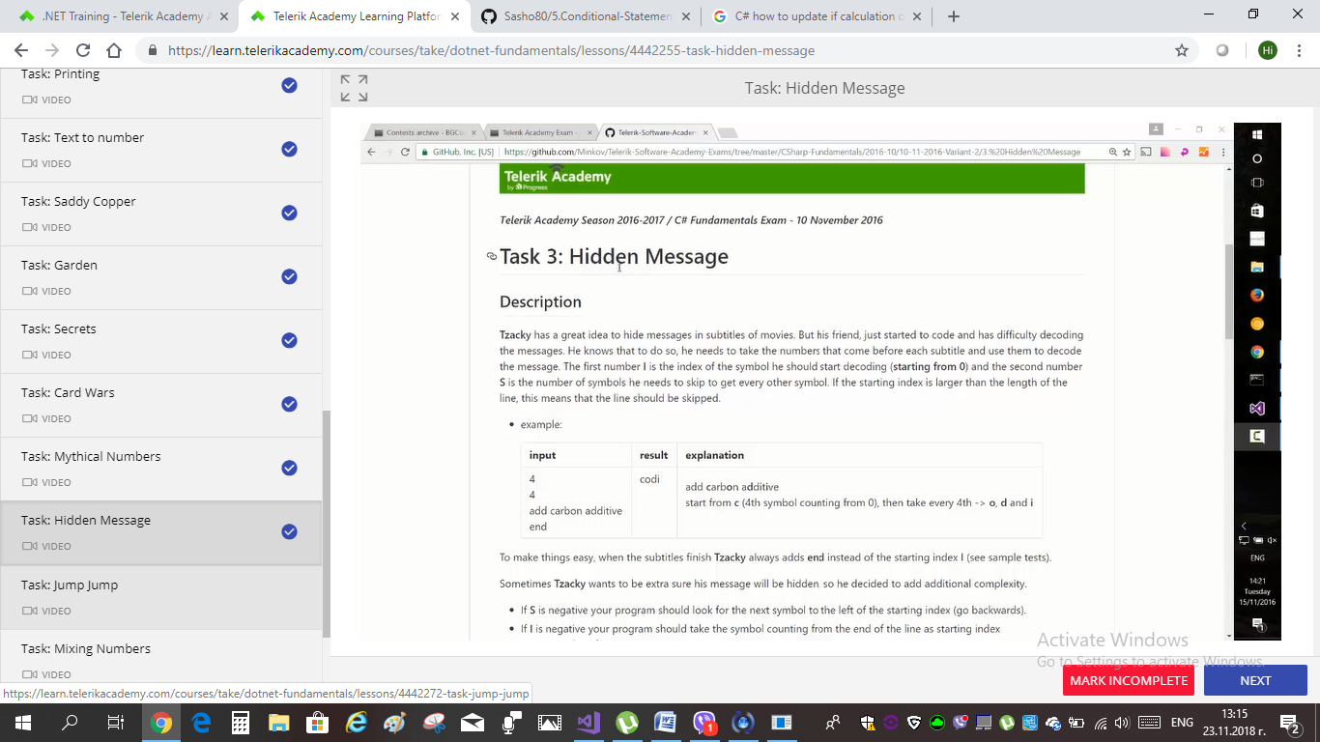

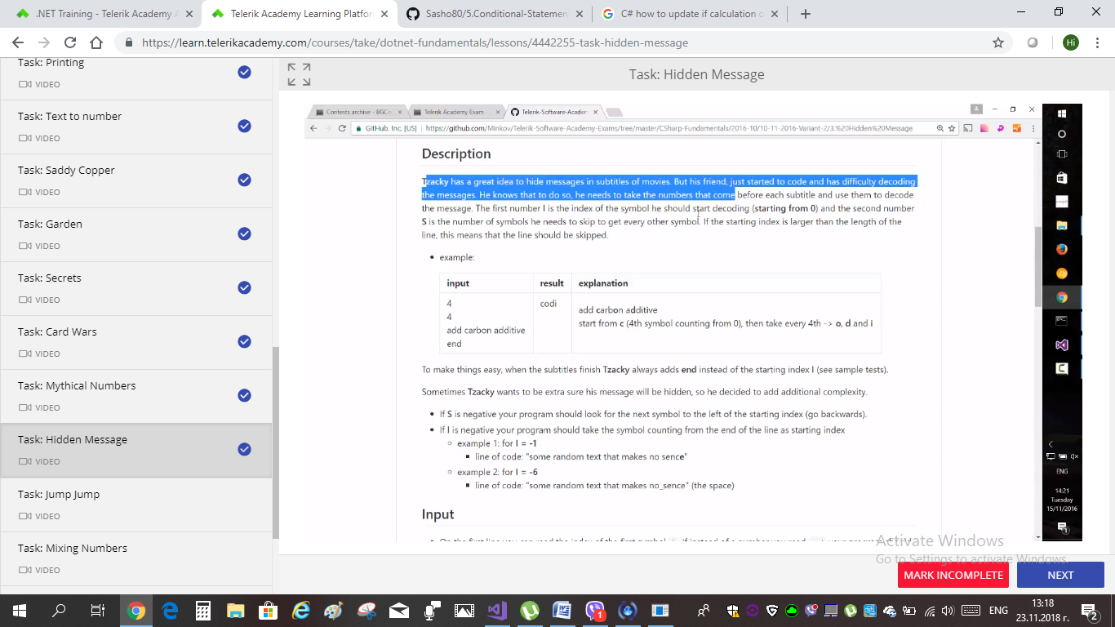

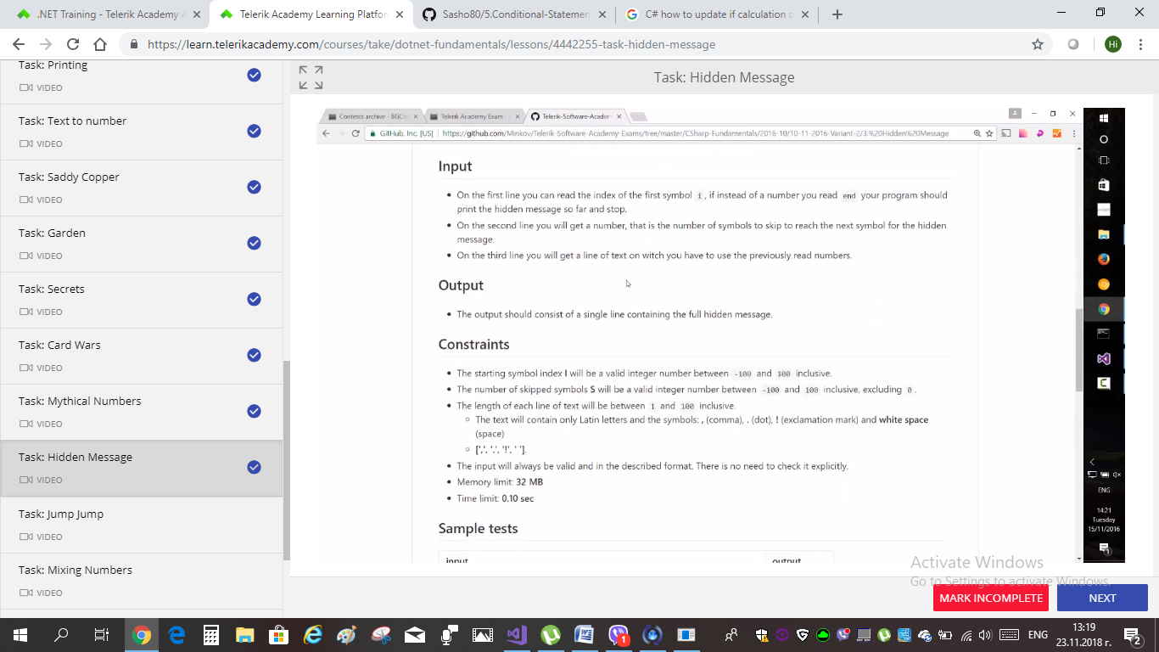

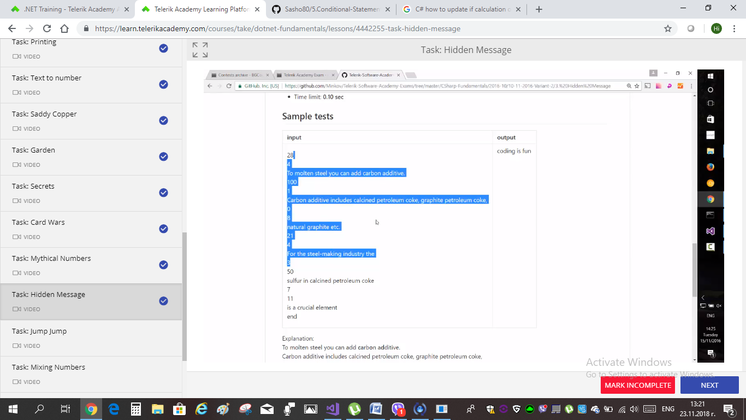

VIDEO SOLUTIONS – TELERIK ALPHA C#

EX. 7 “MYTHICAL NUMBERS” – below is the TASK:

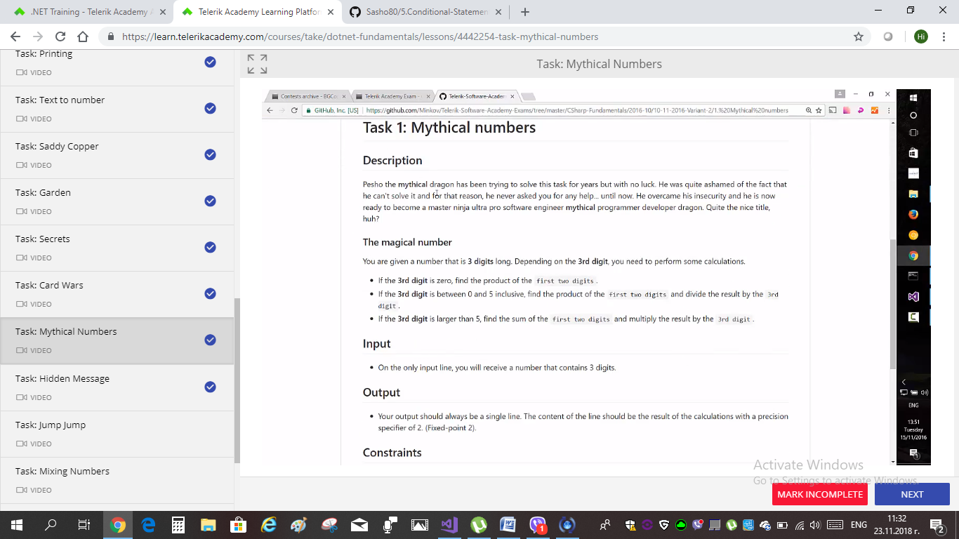

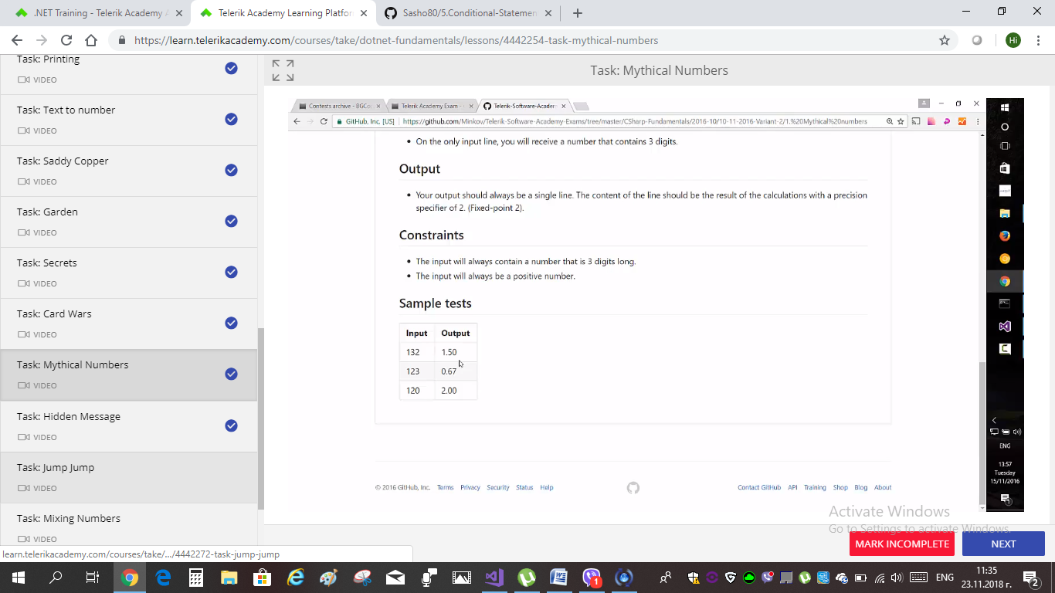

VIDEO SOLUTIONS – TELERIK ALPHA C#

EX. 6 “CARD WARS BATKA” – below is the TASK:

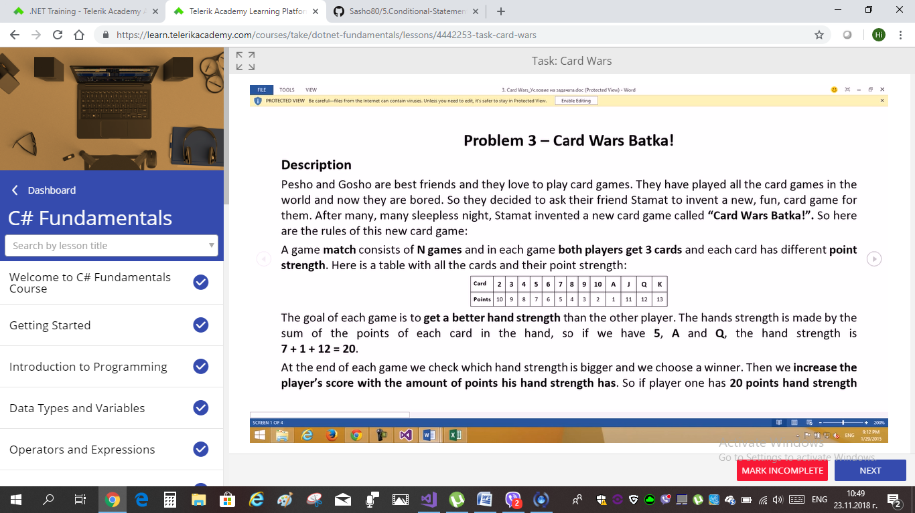

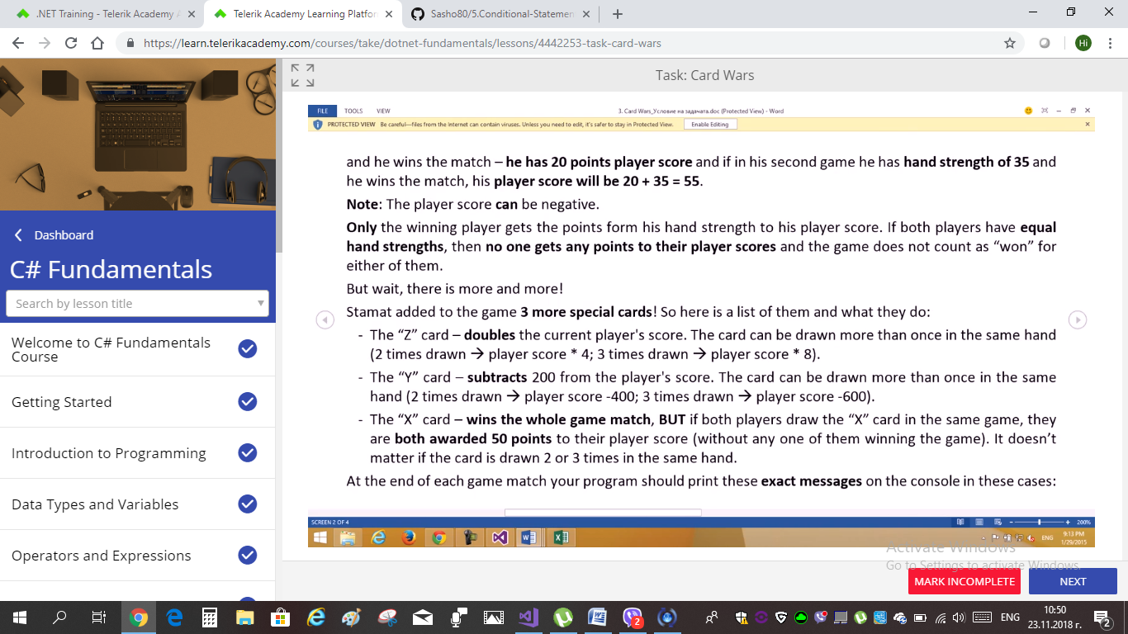

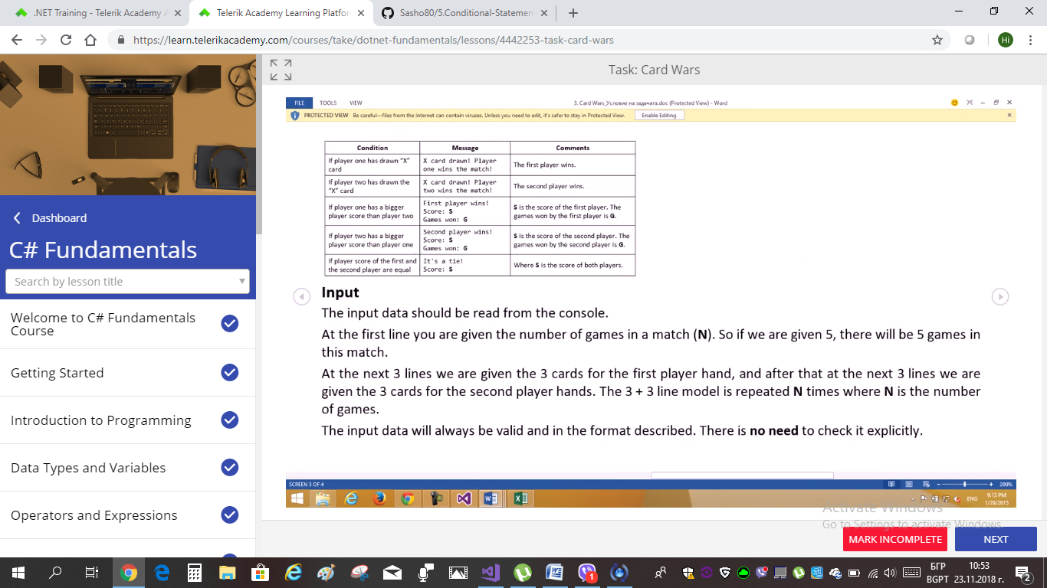



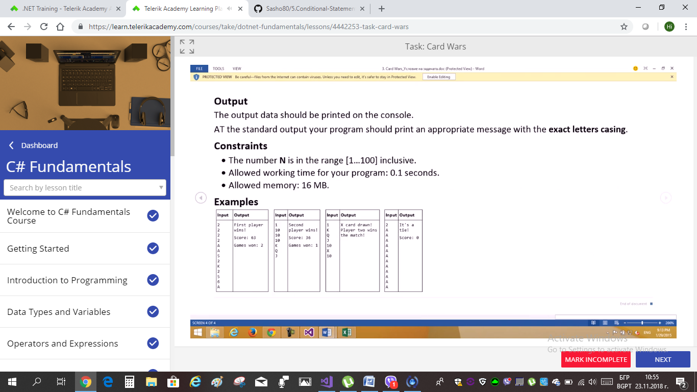

VIDEO SOLUTIONS – TELERIK ALPHA C#

EX. 5 “Secrets” – below is the TASK:

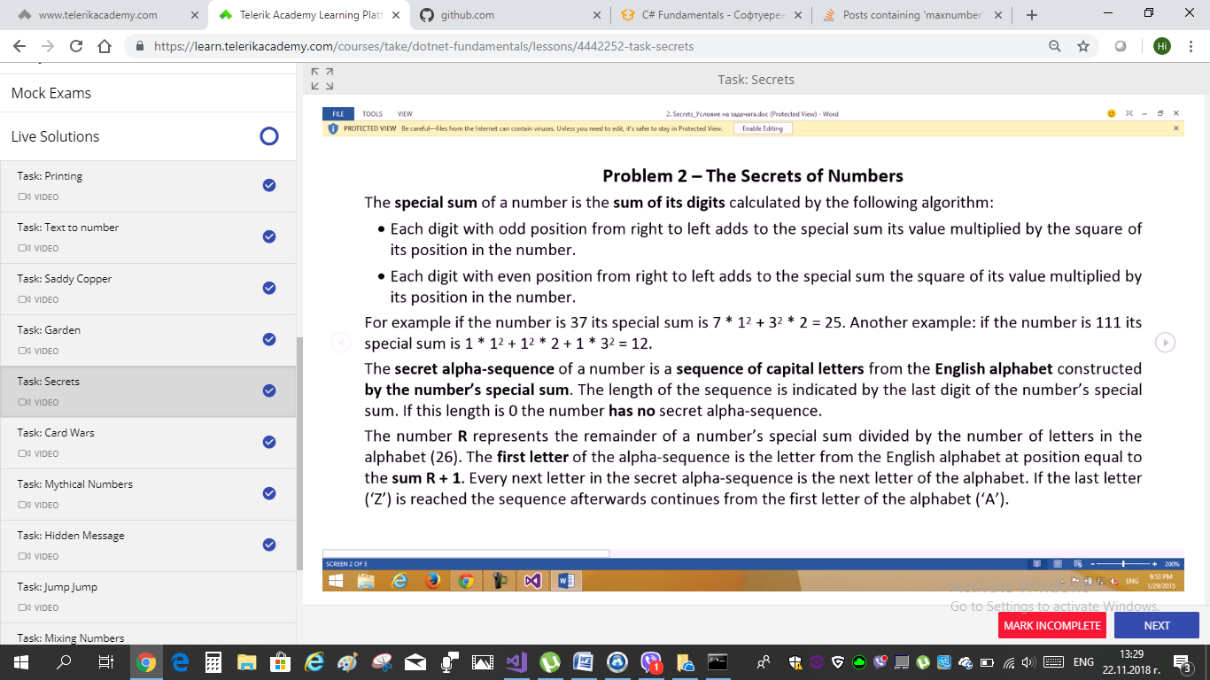

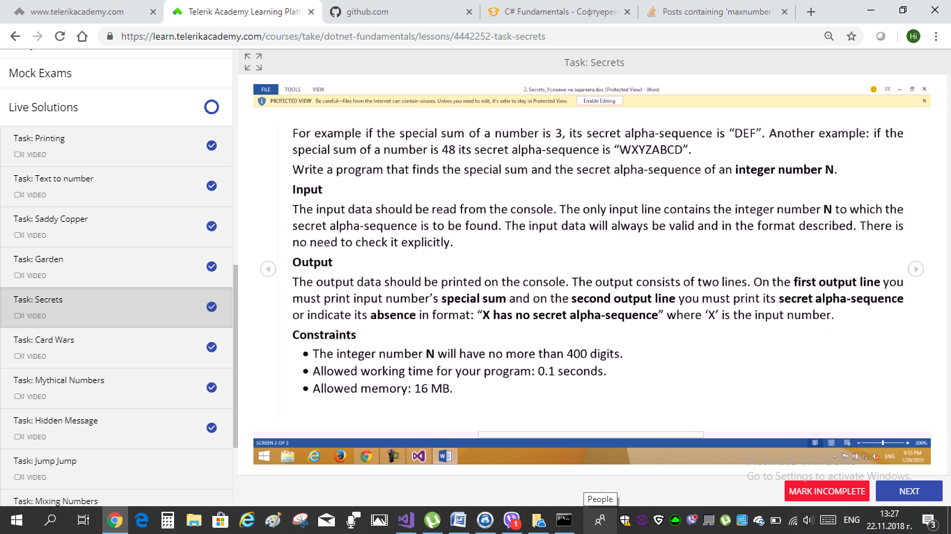

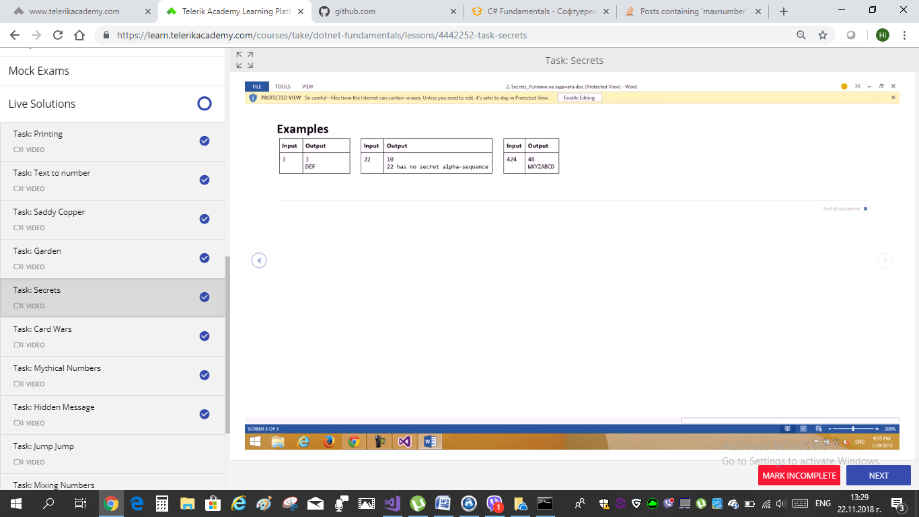

VIDEO SOLUTIONS

EX. 4 “GARDEN”

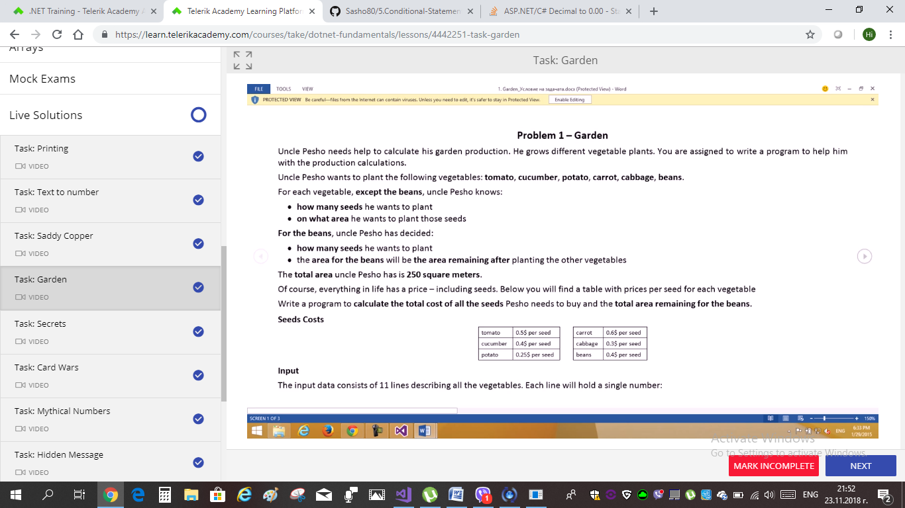

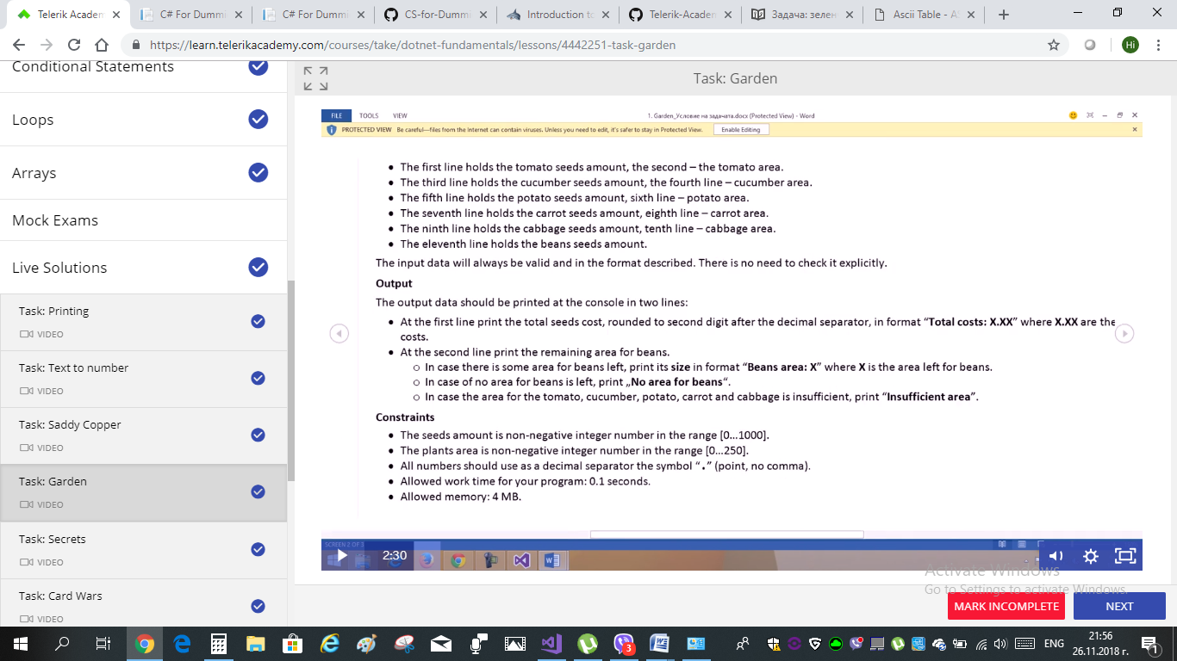

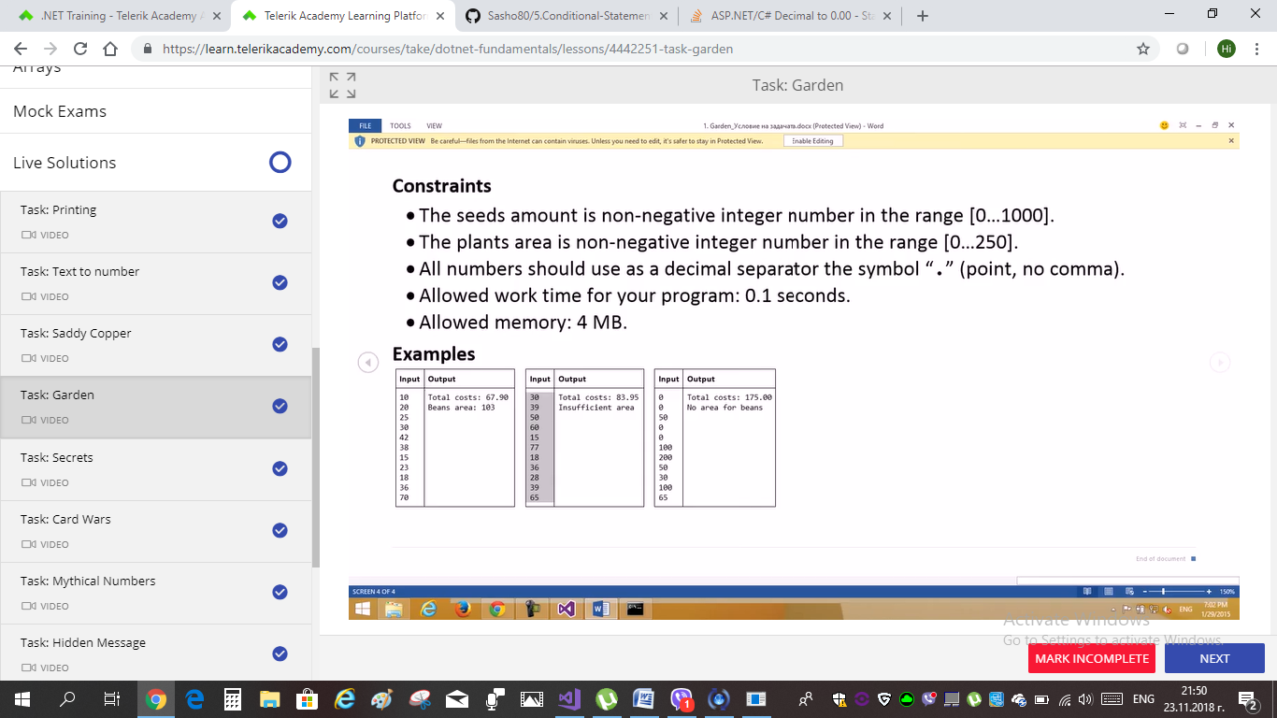

below are the sample input row sets of EX.4 “GARDEN”

Input 1: also found in Text. Fie “Sample.Input.txt.”

10

20

25

30

42

38

15

23

18

36

70

Input2:

30

39

50

60

15

77

18

36

28

39

65

Input 3:

0

0

50

0

0

100

200

50

30

100

65

VIDEO SOLUTIONS

EX. 3 “Saddy Kopper”

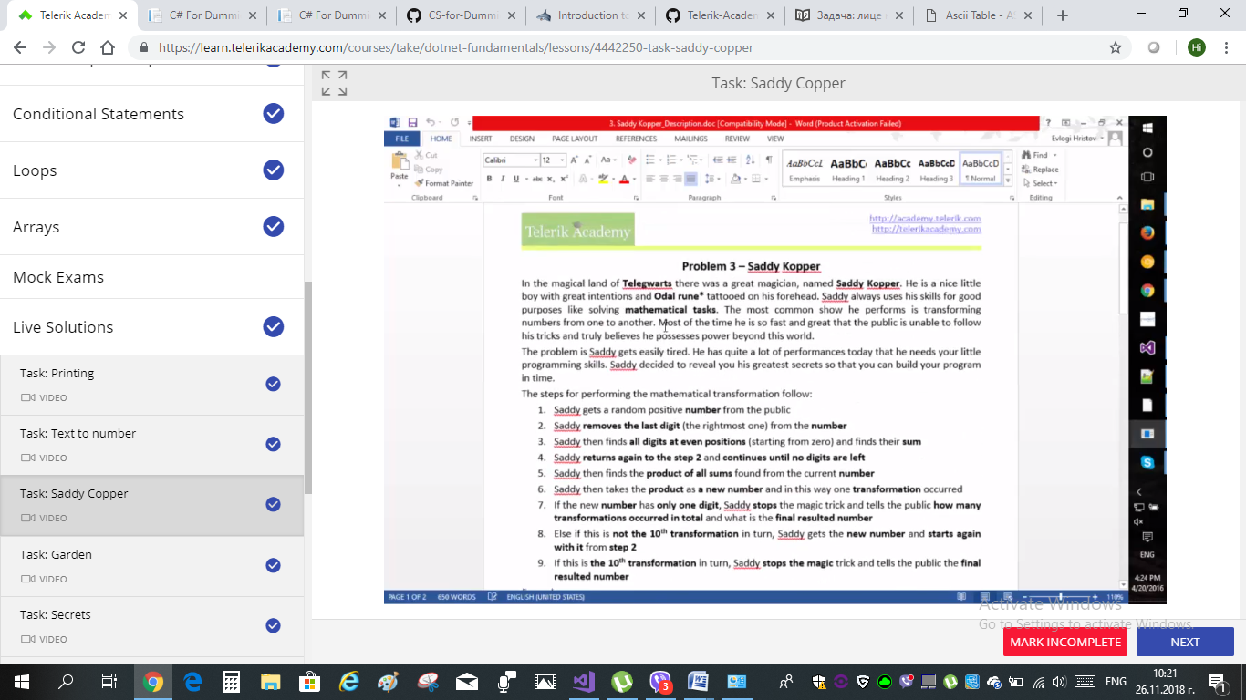

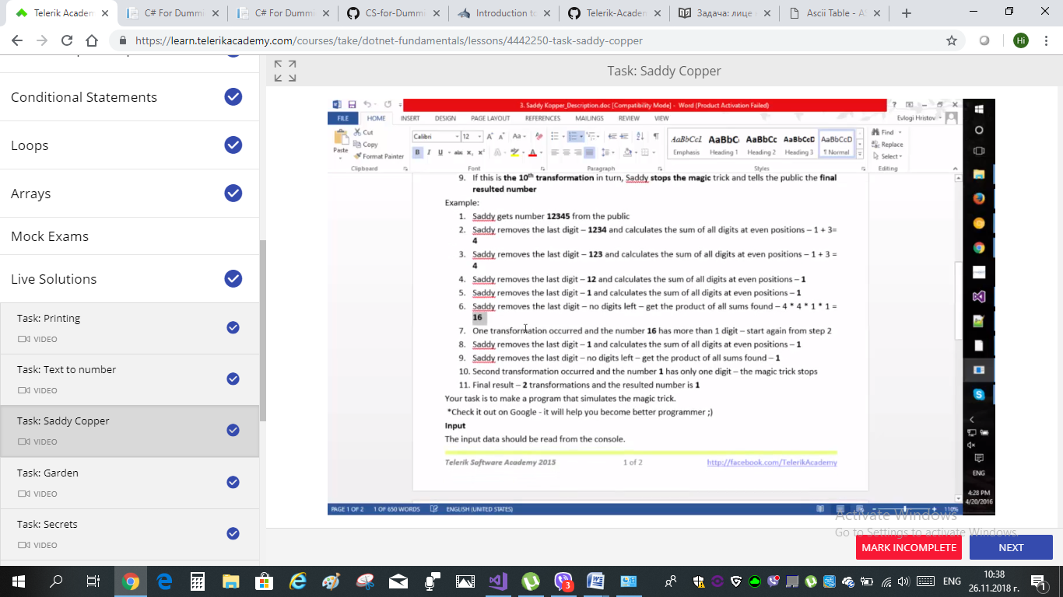

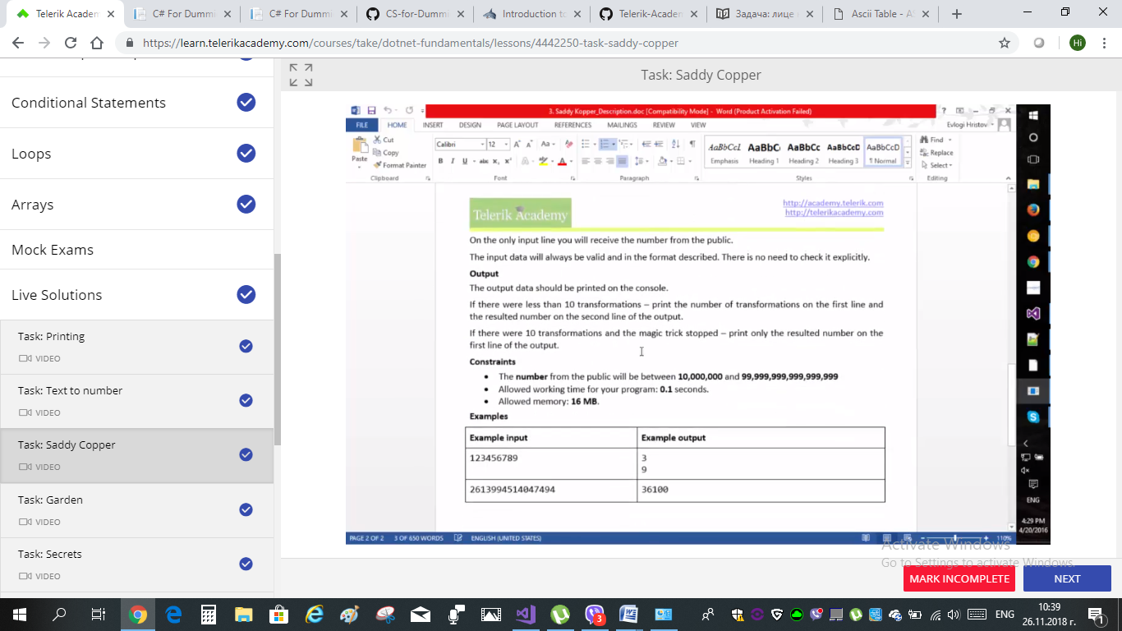

VIDEO SOLUTIONS

EX. 2: “Text to Number”

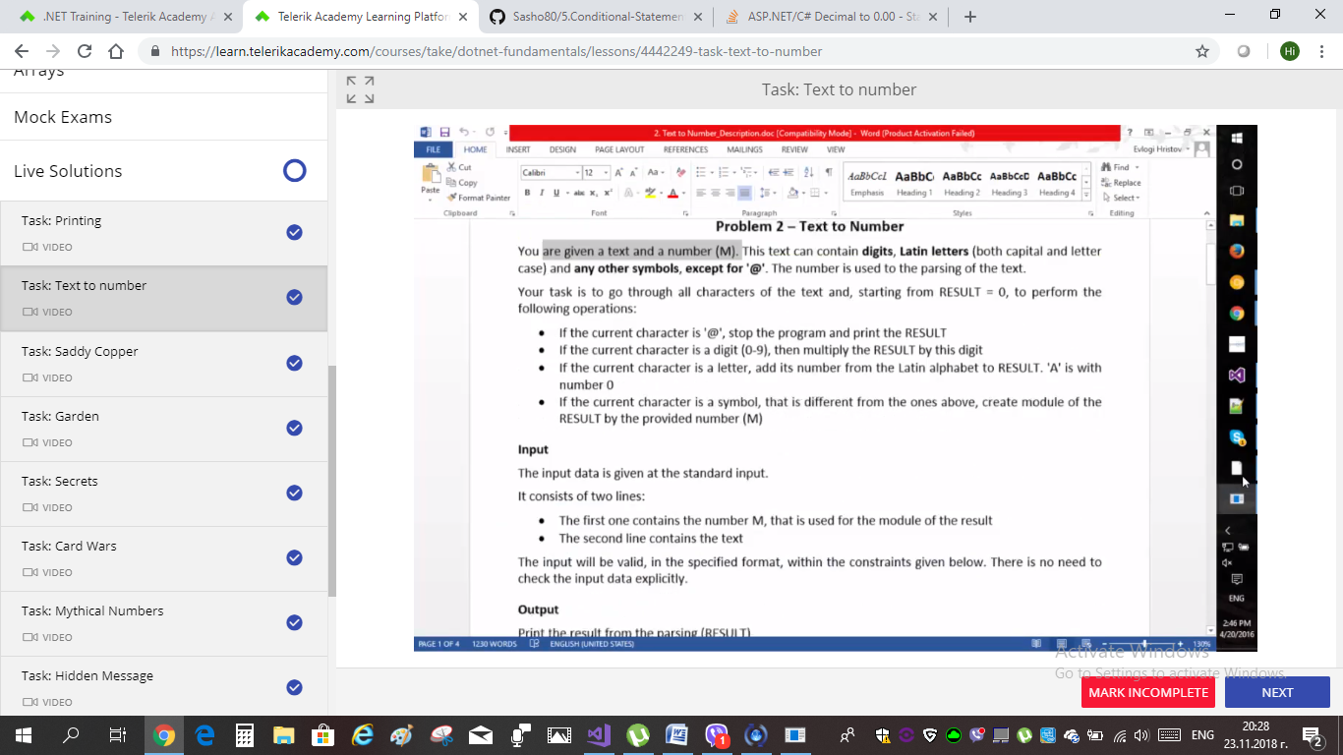

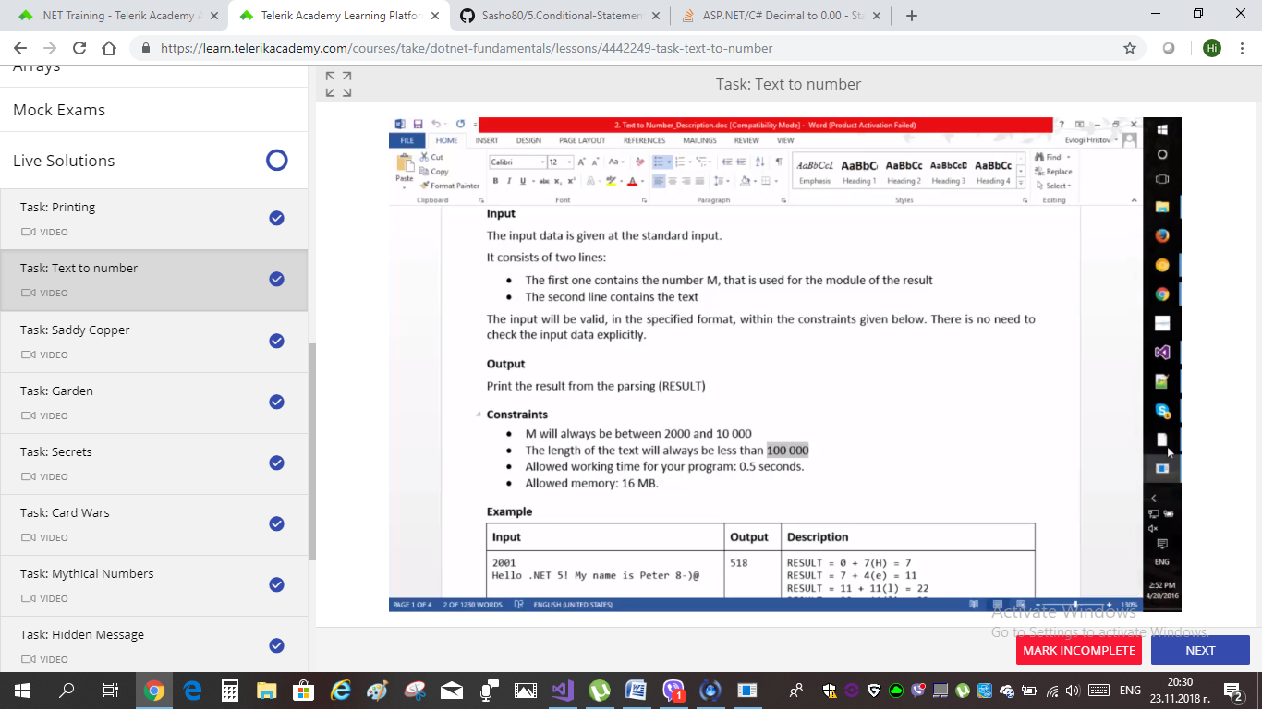

EX. 1 “Printing”

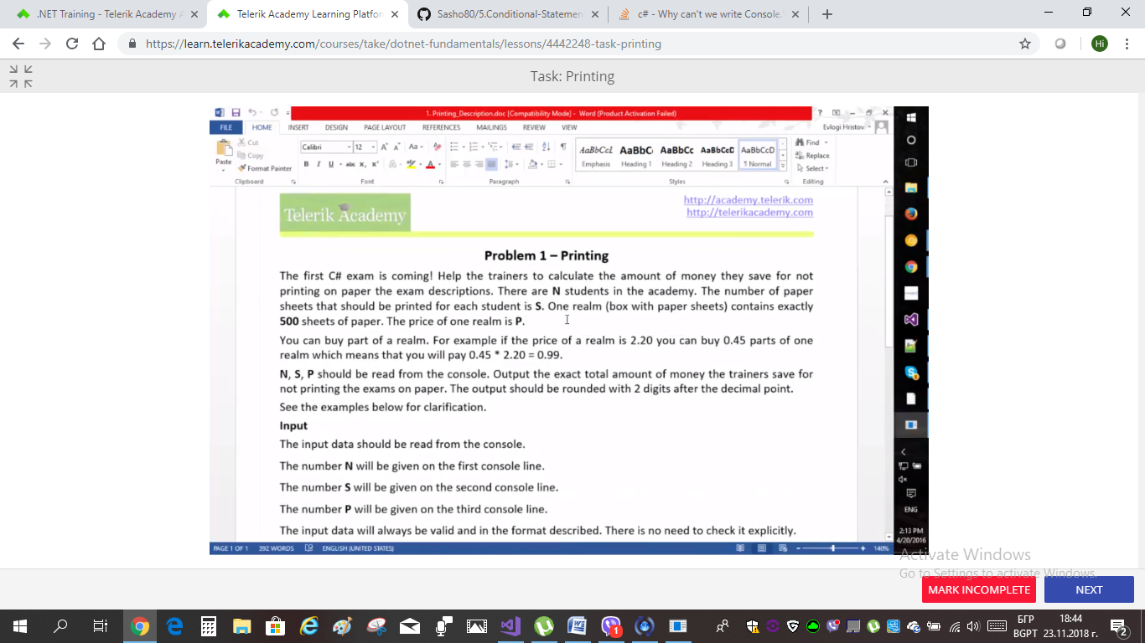

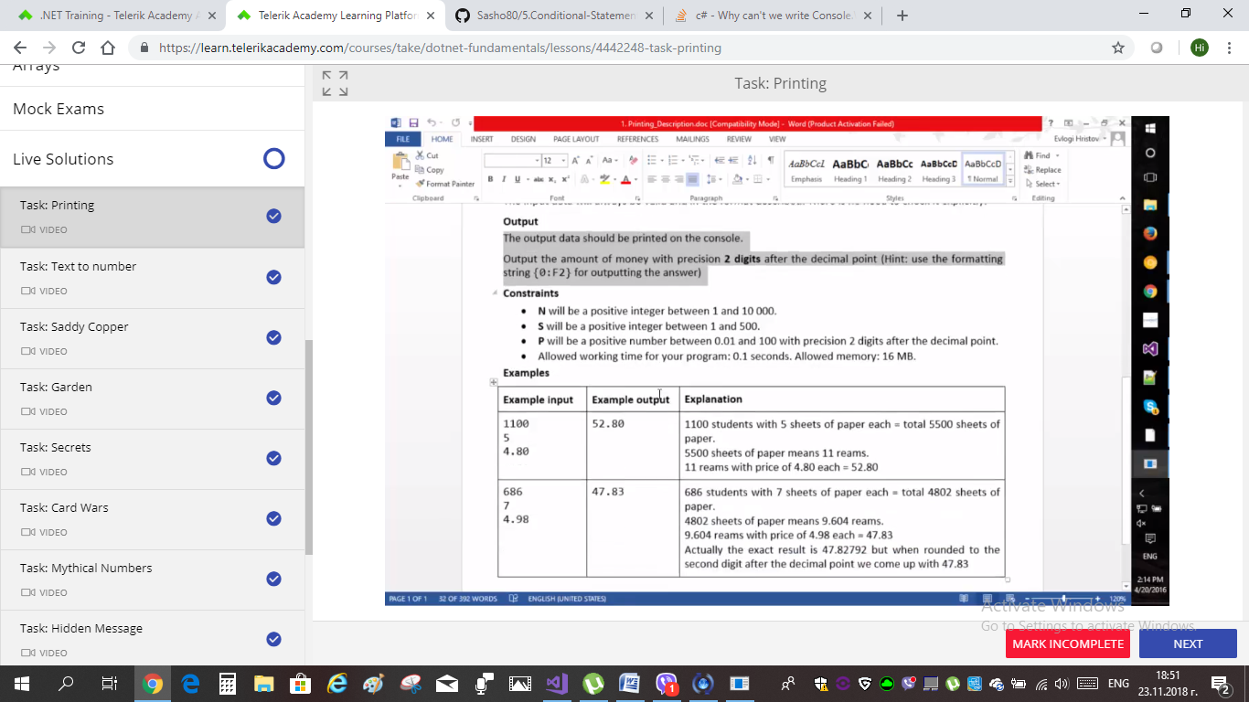

using System;

namespace LiveSolutions

{

class Program

{

static void Main(string[] args)

{

//EX.1: "PRINTING"; Using C# tools:

int numStudents = int.Parse(Console.ReadLine());

int sheetsPerStudent = int.Parse(Console.ReadLine());

double price = double.Parse(Console.ReadLine());

double realm = 500; **//changed to double**//1 realm has exatly 500 sheets of paper

//logic

// double result = 0; //taka go vavedohme, v nachaloto na reshenieto - sega promenqme:

double result = numStudents * sheetsPerStudent / realm * price;

///нямаше нужда от каствания и скоби!! проблемът беше, че КОНЗОЛАТА иска запетая, а не точка . //castvaneto, opisano po-dolu ne deistva, zatova gore gi smenih na double gi pars-nah

///cast-vam explicitly kum (double) ''realm'' , koito sum inicializirala kato int ///ako ne go kastna, shte se izgubi delenieto s ostatyk - a po uslovie

///iskame to da e {0.00} ,което посочваме накрая в конзол райтлайн

**/////variant 2 e prosto da mu promenq gore inicializaciqta na (double realm = 500;)**

///double result = numStudents * sheetsPerStudent / (double)realm * price;

///tuk si ostava gore

///int realm = 500;

//result

Console.WriteLine("{0:0.00}", result); //тук пишем формата 0.00 с точка, но в конзолата " ,"!

}

__________________________________________________________

Н.Ч.Г.

INT/ long/ BigInt (examples: ex.2, ex. 6)

WriteLine cannot function inside if{} (example ex. 9)

Char reading (example ex. 2)

Съчетание на реда на ИНПУТ и реда на КОНЗОЛ.РИЙДЛАЙН

///poprincip CHAR:

///(char)('A' + 0) printira A

///(char)('A' + 5) printira F

//(char)('a' + 2) printira c

///('A' + 0) printira unicode na A=65

///('b' + 1) printira unicode na c=(98+1)=99

///'5' printira char 5

///('5' - '0') printira chisloto 5!!!